**DAILY ONLINE ACTIVITIES SUMMARY**

|  |  |  |  |  |  |  |  |
| --- | --- | --- | --- | --- | --- | --- | --- |
| **Date:** | **26/06/2020** | | | | **Name:** | **Sinchana K N** | |
| **Sem & Sec** | **IV sem & B section** | | | | **USN:** | **4AL18CS083** | |
| **Online Test Summary** | | | | | | | |
| **Subject** | | **-** | | | | | |
| **Max. Marks** | | **30** | | **Score** | | **-** | |
| **Certification Course Summary** | | | | | | | |
| **Course** | **Excel for beginners** | | | | | | |
| **Certificate Provider** | | | **Greatlearning academy** | **Duration** | | | **4.5hours** |
| **Coding Challenges** | | | | | | | |
| **Problem Statement1:** Given start and end of a range, write a Python program to print all negative numbers in given range. | | | | | | | |
| **Status: Executed** | | | | | | | |
| **Uploaded the report in Github** | | | | **YES** | | | |
| **If yes Repository name** | | | | **https://github.com/acchu1234sinchana/Lockdown_coding1** | | | |
| **Uploaded the report in slack** | | | | **YES** | | | |

Online Test Summary: No internals conducted today.

Online Certification Course Summary: In today’s session I have learnt about if else, data cleaning, substrings.

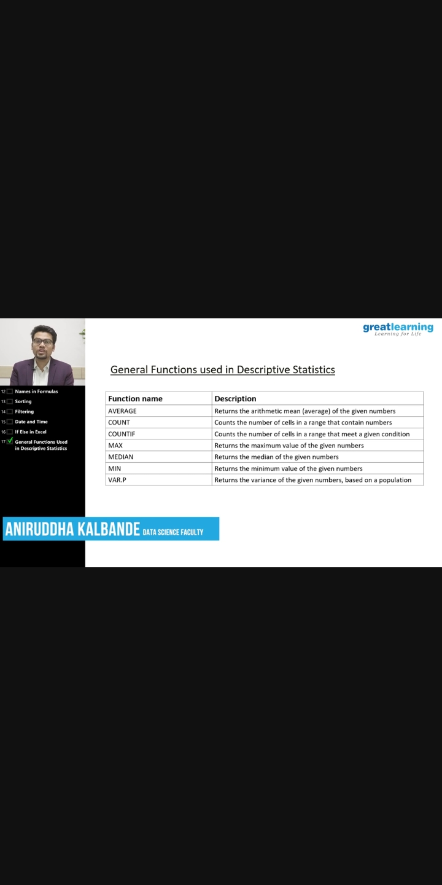

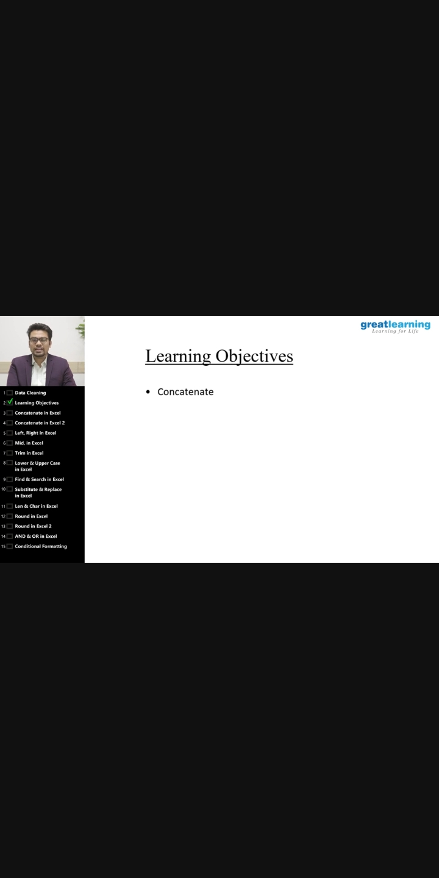

Online Coding Summary: **Today I had received one program from prof. Vasudev CSE Dept. The program is mentioned above in the coding challenges(pg.01). I have also uploaded it to my Github repository.**

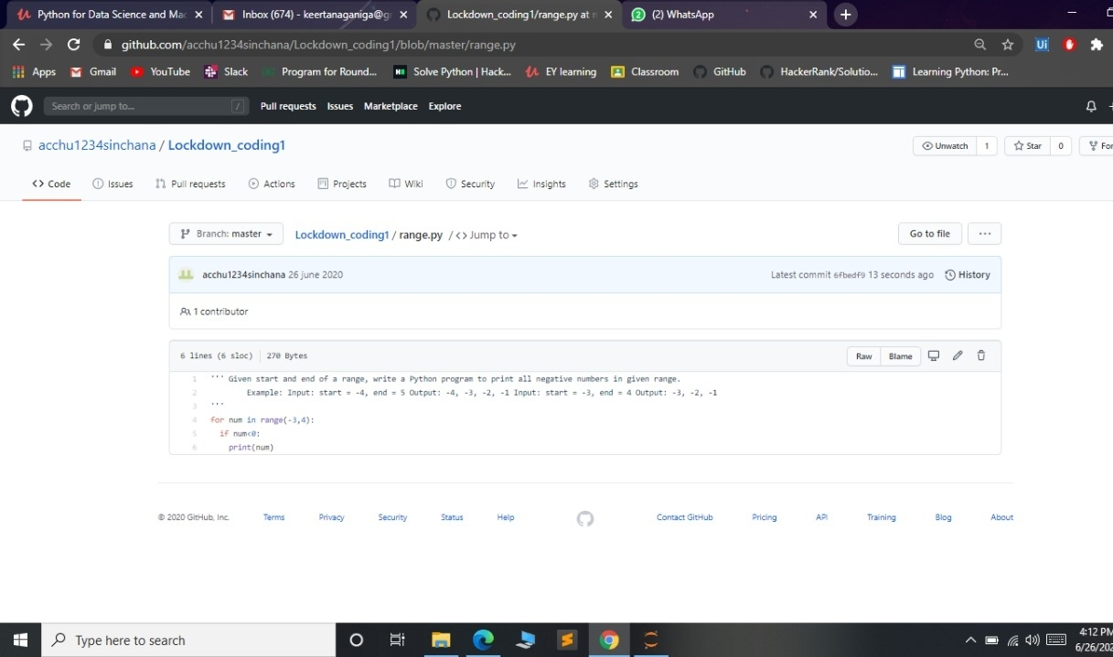

Online Training: Today I had attended the online training organized by CSE Department AIET. The training was on Cyber Security and its Applications done by Dr. Manjunath Kotari HOD CSE Dept.